BMW Global Sales Quieries
KPI’S
- Total Revenue:

- Average BMW Value

- Total BMW’s sold?

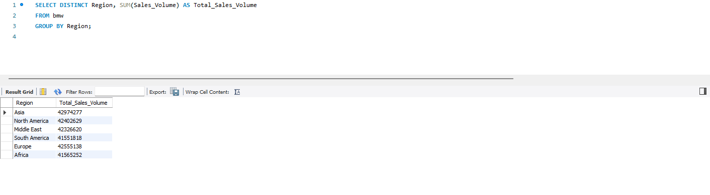
- Total BMW’s sold per region?

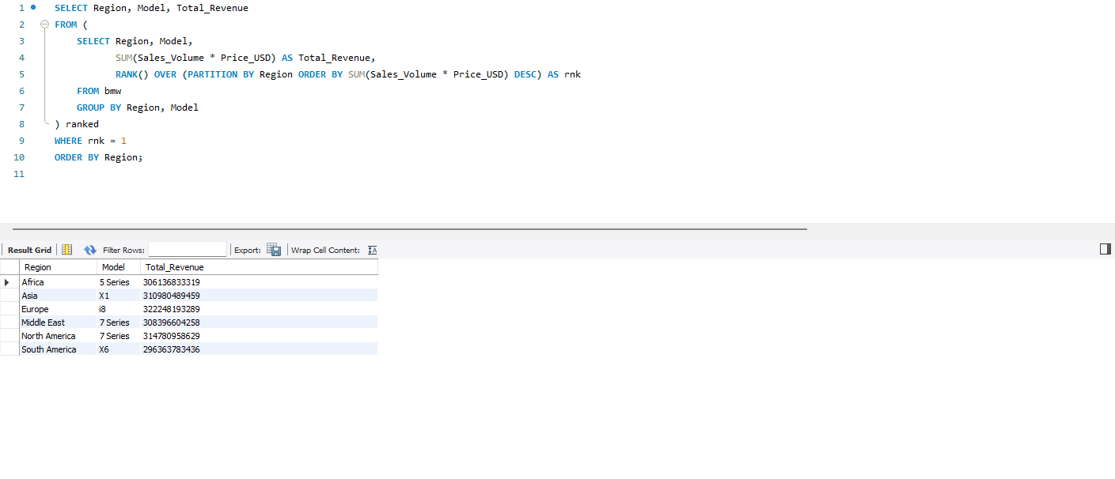
- Best selling model per region?

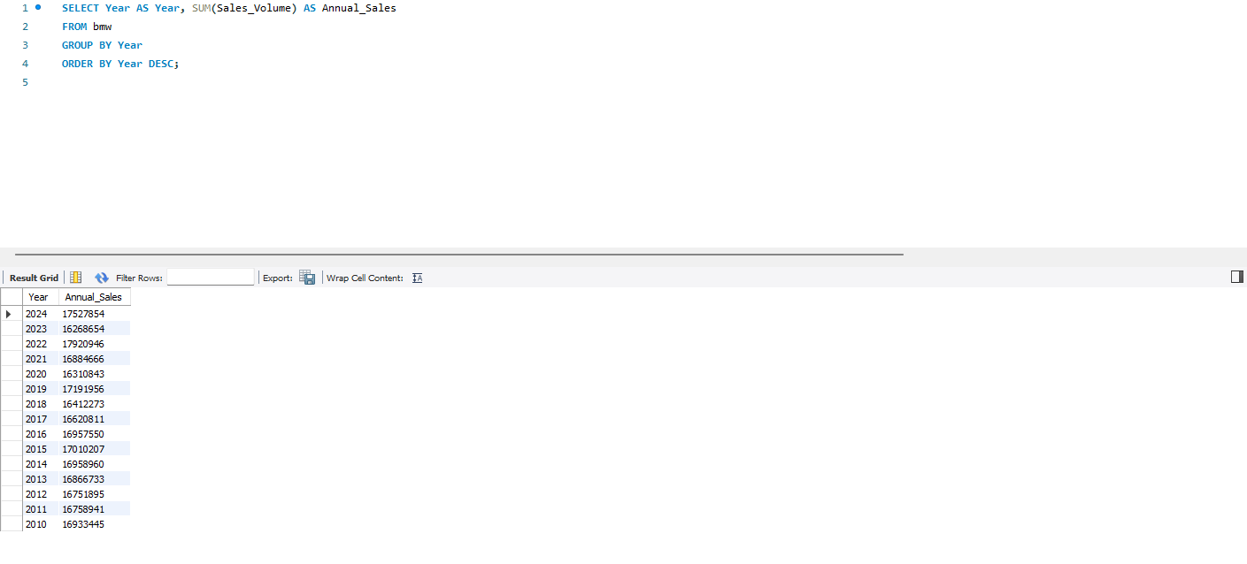
- Trend: Bar Chart displaying Annual Sales from 2010 - 2024

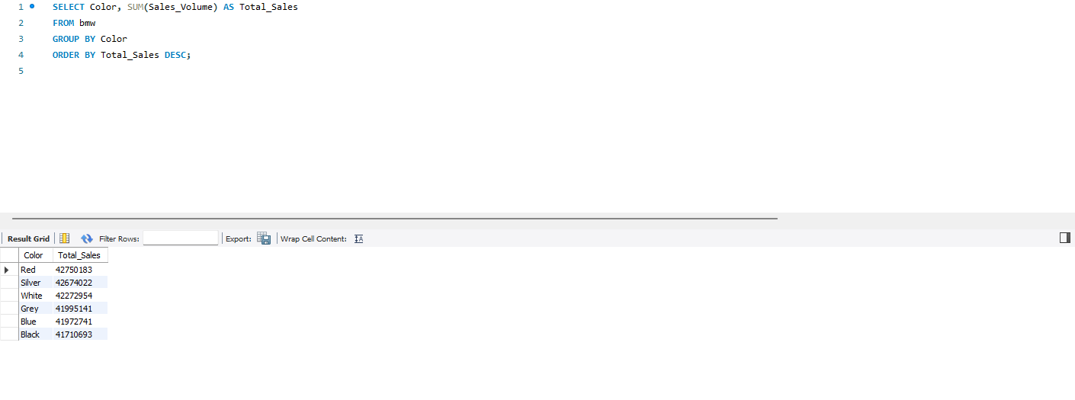
7. Trend: Chart displaying Total Sales based on Color

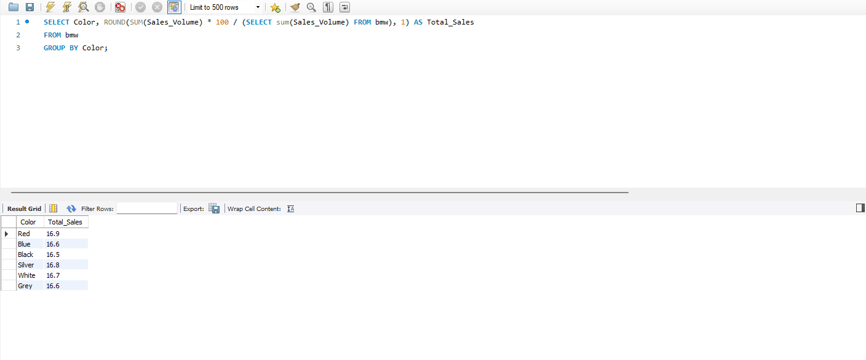
8.Percentage of Sales by car color

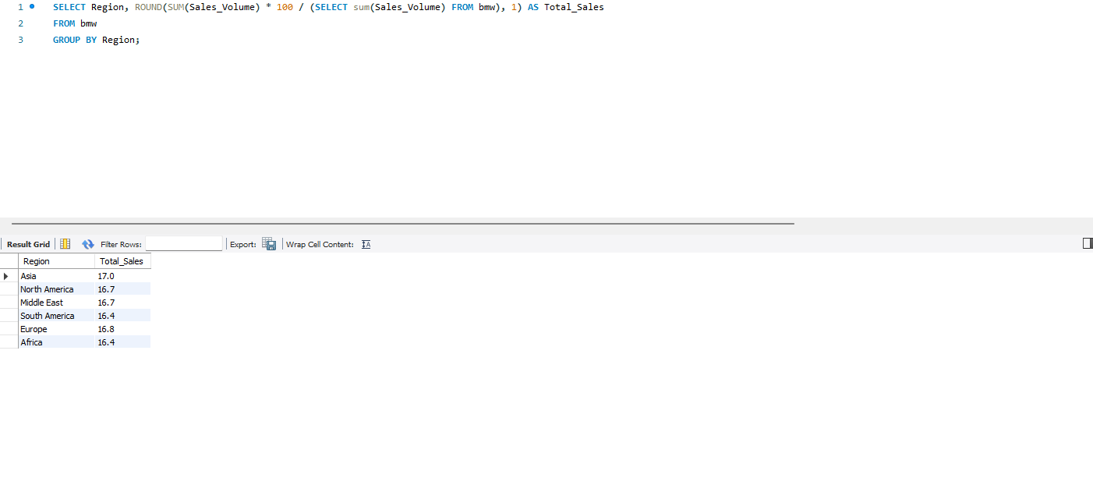
10.Percentage of Sales by Region

11. Total Cars sold by Transmission type
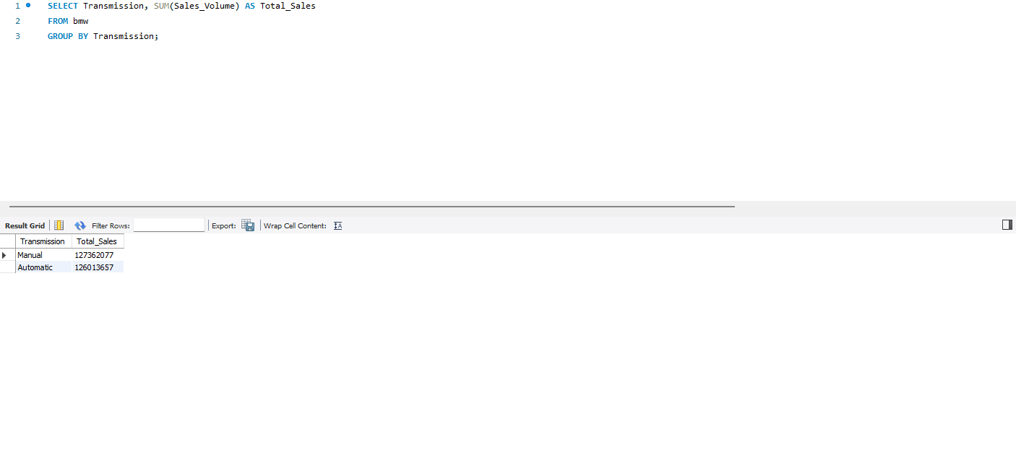

12. Top 5 best sellers by Revenue.

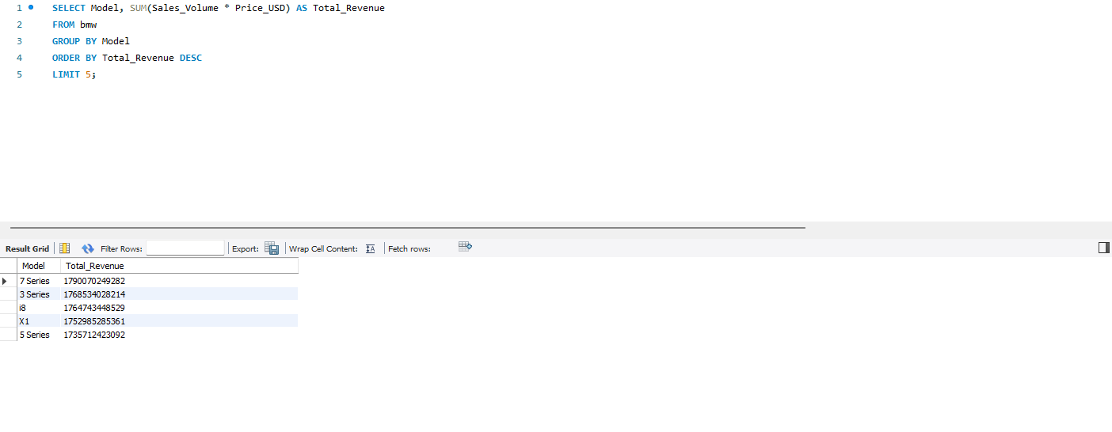

13. Bottom 5 sellers by revenue
